NOVAC Technology Solutions



Business Requirement Document

For

SGI Philippines – Policy Receipt Screen in NOVA Application

Revision History

Version No. | Date | Reason For Changes | Author | Reviewer | Approver
Draft 2.1 | 10-Jan-2025 | Draft document for to add the multiple instrument details in the Receipt screen | PL.Nijanthan | M. Arunkumar | Mr. Manoj Joseph
3.0 | 17-Jan-2025 | Baseline document of draft version 2.1 | PL.Nijanthan | M. Arunkumar | Mr. Manoj Joseph

Table of Contents
1. Introduction 4
1.1. Purpose 4
1.2. Project scope 4
1.3. References 4
2. Functional Overview 4
2.1. Assumption and Dependencies 5
3. Interface Requirements 5
3.1. Internal Interfaces 5
3.1.1. Hardware Interface 5
3.1.2. Software Interface 5
3.1.3. Communication Interface 5
3.2. External Interfaces 5
3.2.1. Hardware Interface 5
3.2.2. Software Interface 5
3.2.3. Communication Interface 5
3.3. Operating Environment Requirement 5
3.3.1. Hardware Requirements 5
3.3.2. Software Requirements 5
3.3.3. Network Requirements 5
3.3.4. Operational scenarios 6
3.4. Non Functional Requirements (NFR) 6
3.4.1. Reliability 6
3.4.2. Performance 6
3.4.3. Security 6
3.4.4. Usability 6
3.4.5. Other Requirements 6
3.5. Open Issues 6
3.6. Acceptance Criteria 6
4. Appendix A 6

Introduction

Purpose
The purpose of this requirement is to add the multiple instrument details in the policy receipt screen if Adjust Commission check box selected.
  - Guidelines, circulars, instructions and directions released from time to time by Philippines Insurance council.

Project scope
To capture the multiple instrument details whether the Adjust Commission check box selected or not.

References

Functional Overview

In the current policy receipt screen, system is restrict to capture the multiple instrument details if the Adjust commission check box selected.
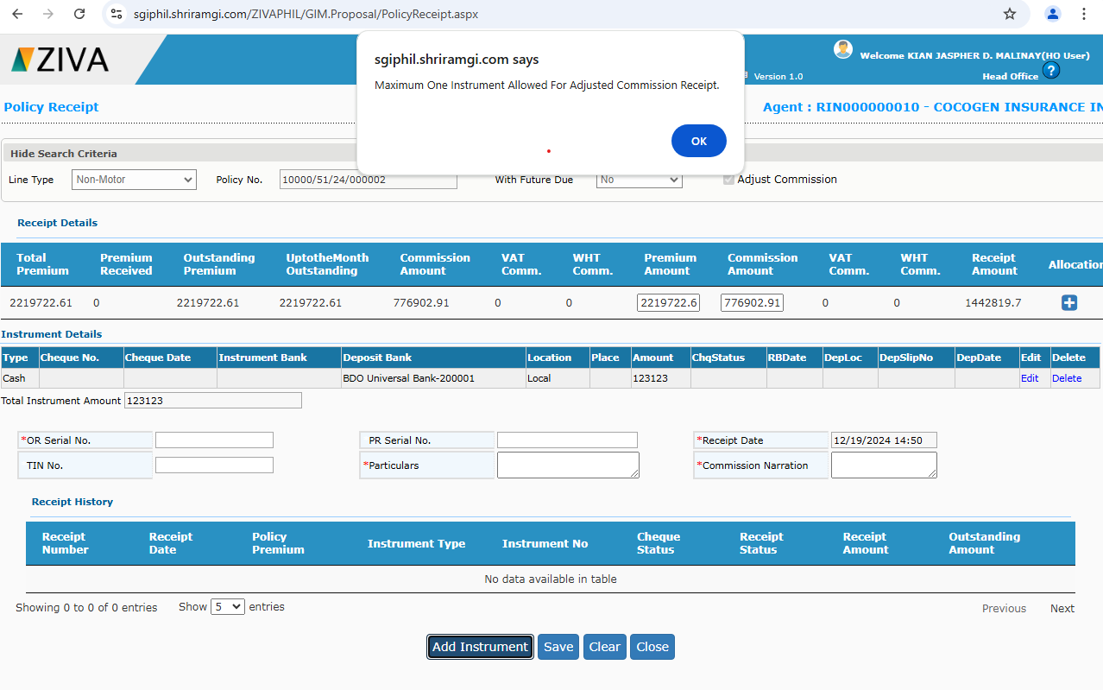
Now system is required to capture multiple instrument details in the policy receipt screen if Adjust Commission check box selected, the same function should be followed when the check box of Adjust commission is not selected.

Assumption and Dependencies
<Not Applicable>

Interface Requirements

Internal Interfaces

Hardware Interface
<Not Applicable>

Software Interface
<Not Applicable>

Communication Interface
<Not Applicable>

External Interfaces

Hardware Interface
<Not Applicable>

Software Interface
<Not Applicable>

Communication Interface
<Not Applicable>

Operating Environment Requirement
<Not Applicable>

Hardware Requirements
<Not Applicable>

Software Requirements
<Not Applicable>

Network Requirements
<Not Applicable>

Operational scenarios
<Not Applicable>

Non Functional Requirements (NFR)

Reliability
<Not Applicable>

Performance
<Not Applicable>

Security
<Not Applicable>

Usability
<Not Applicable>

Other Requirements
<Not Applicable>

Open Issues
<Not Applicable>

Acceptance Criteria
- Functional testing will be executed by internal testing team, and the same will be delivered to client for UAT.

Appendix A
Not Applicable

